HTML Lab 1

1.1 Creating Web Pages

Web pages are created using HyperText Markup Language ( a subset of Standard Generalized Markup Language).
The server, where the web pages are stored, sends the web page with all the page layout instructions and information on what should be included on the page to the client e.g. a web browser such as internet explorer. These instructions are encoded in HyperText Markup Language. To create a web page we must therefore learn to use html and/or an application that will generate html. The hypertext mark-up language (html) is not a programming language but a page layout language. HTML instructs the browser how to display the contents of the page, such as when to format text with bold, underline, italic and other such formatting. The markup language also tells the browser how to layout text and graphics, and also where to find the graphics and any other multimedia elements such as sounds and video on the computer that’s actually serving the Web pages.

HTML consists of tags that tell the browser how to render html text and elements. For example if we wish a piece of text to be bold then we would surround that text with the bold tags:
<b> this text will be bold</b> this text won’t
Note: we are using html but to be compatible with the newer xhtml we will use only lower case for the tags.

Turn bold on tag
Turn bold off tag

Therfore this would appear in the browser as:
this text will be bold this text won’t

As seen in the browser

Similarly if we wish to italicise text

<i>this text will be Italic</i> this text won’t
this text will be italic this text won’t

tags can be nested to create formatting such as bold, italic and underlined:
<b><i>this text will be bold and italic </i></b> this text won’t
this text will be bold and italic this text won’t

Note: the way the tags are opend and closed when nested i.e. the last one opened in the nest is the first one closed e.g. <b><i> …</i></b>

1.2 The HTML Document Structure

When creating the HTML there is a specific structure that we should follow.
The first tag is the <html> tag and lets the browser know that it is an html document. The last tag of the document is </html> and all other tags and text within the document are contained within these tags.

The structure within an HTML document essentially consists of two different sections. The first section is for information about the document and will not be seen by the client when viewing the page in the browser; this is the header section and is contained between <head>..</head> tags.
Begin HTML

<html>

<head>

</head>

<body>

</body>

</html>

The Head tag contains information about the document that you don’t want to appear on screen.

The HTML that will appear in the browser is contained with the <body> </body> tags i.e

End HTML

1.3 Creating the Document

HTML documets are text files which are structured in a particular way so that they will be recognised as an Html file.
To create a basic page we can use a simple text editor such as notepad, simply open up the application and type the html document in as seen here:

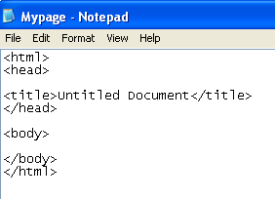
Whatever text is placed between the title tags appears in the title bar of the Browser window. The Title tags are placed between the Head tags.

Remember to close the tags! Both <head> and <title> tags require a close tag, </head> and </title> respectively.

1.4 The Document Body

All the html that is seen within a web page in a browser is contained between the <body>..</body> tags.

Begin the documents body
<body>
Html to be seen in browser
</body>

End the documents body

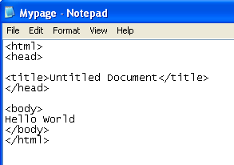
The title of the document is ‘MyPage.html’. Note this does not have to be the same as the name of the document it is saved under and most often is not.
The body contains only the text ‘Hello World’.

This is how this document would be rendered by the browser:
The title appears in the title bar.
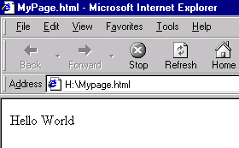
The location of the document appears in the address bar.
What is actually seen on the web page is only the html that is contained within the body tags.

1.4.1 Where to create the document:
To open notepad:

Select : Start at the bottom left of your screen and subsequently from the menus
Programs,
Accessories,
and notepad

and the notepad window should open and you will be able to being typing your document.
Any other wordprocessor can be used, but note that html files must be saved using the html file extension which denotes a formatted web page.

1.5 Saving The HTML File

In notepad or any other application you therefore need to ensure that the document is saved with the extension added to the file name. You need to do this to stop notepad adding a .txt file extension to your page. If you don’t have the correct file extension, .html, the browser won’t read it properly.

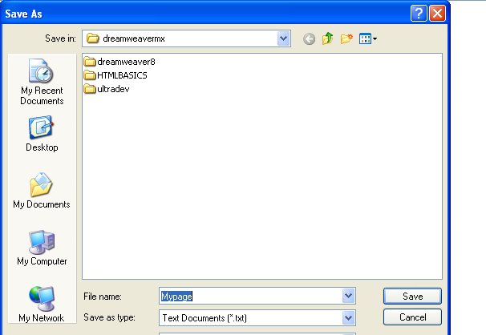
Use a name of choice add in the .html extension and it will be recognised as an html file.
The type of document is a text only (or save as file type ‘any’ )

As with most applications after the intial ‘save as’ you can simply select save to subsequently update changes made to the file.

1.6 Updating the page

When we make changes to the web page the changes are written in the text editor or application that we are using to create the web page. We then need to save the changes and view the updated change in the browser.

Changing and updating example:

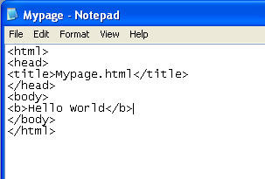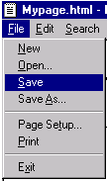
Here we have made a change by surrounding the text with <b> and </b> tags, signifying bold and end bold.

We then update the changes by saving the file.
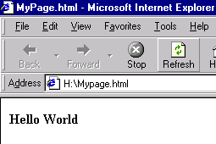
To see the update in the browser simply select the refresh button or press F5.
Here you can see the change i.e. the text has been rendered bold.

There is no need to close down either application; simply work between the two and when you update the html in notepad (or whatever editor you happen to be using) save the file then select the browser (which will be minimised at the bottom of the screen and select refresh to see the update of the web page.

Similarly when you wish to update again: select the editor and type in the changes, save, select the browser and choose refresh .

We will now go on to look at creating a fairly substantial text document (a C.V.) as a web page using html.

2. Creating a CV

In this lab you are going to create a cv document using HTML.
This will provide practice in basic use of html tags. The first section consists of an example cv which you can reproduce by following the subsequent sections.

2.1 Curriculum Vitae

John Smith

Address: Flat 3/2
3 George Place
Paisley
PA1 2HY
Tel no: (0141) 848 3329
Email: smit-ci0@paisley.ac.uk
Date Of Birth : 20/09/70

Skills Profile

I am an enthusiastic and ambitious individual who has gained a wide range of experience through military training and academic study.

- Effective communicator at all levels in all environments.
- Good planning, organisational and time management abilities
- Good leadership skills.
- Enjoy both short term and long term challenges.
- Able to work to deadline and under pressure.

Employment History

- 18/09/00 - present Lecturer Paisley University
- 15/01/99 - 18/09/00 P/T Lecturer James Watt College
- 5/09/98 - 18/09/00 P/T Lecturer Cardonald College
- 1/10/96 - 18/09/00 P/T Lecturer Paisley University
- 30/11/87 - 30/03/93 Royal Navy – Marine Engineering Mechanic

During my career in the Royal Navy I gained much experience and visited many parts of the world. I gained many skills and experience doing numerous tasks and jobs. My main job involved both mechanical and electrical work.

Awards gained :
- Promotion to Marine Engineering Mechanic (1).
- Gulf war medal
- Awarded the Green Beret on successful completion of the Commando Course

Qualifications

- 1994 -1996 M.Sc Information technology Paisley university
- 1987 -1993 B.A. Technology Open University

Present Studies

Completing Post Graduate Certificate in Tertiary Teaching Methods.
Completing Ph.D.

Interests

- Education and Learning
- Web Based Technology
- Sports and Martial Arts
- Outdoor Pursuits

2.2 Formatting For a Browser

The CV in this example is formatted for a word processor (Microsoft Word).
However, browsers do not recognise the formatting of the word processor and therefore all the formatting created will not show and if you open up the document in a browser it will look something like the following:

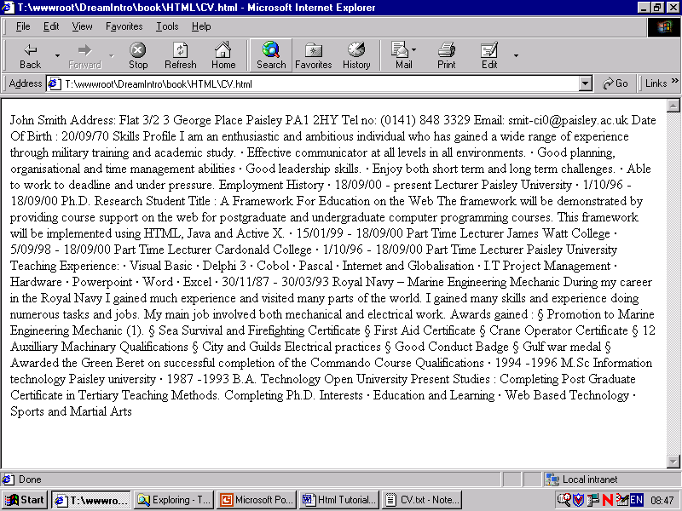

In order for the browser to render the document the way we would want it to be seen we have to tell it how to. We tell it how by using HTML.

The following exercise shows a basic CV document which would need to be formatted in HTML for rendering in a browser. The first 2 pages show the document as we would like to see it and subsequent pages will take you through the actual formatting and the html tags used.

Formatting the C.V.

We need to format the document to be seen in a browser by using Hypertext Markup Language (html) and the various html tags.

We will now look at how to format the first section in the CV for presentation within a browser such as Internet Explorer:

John Smith

Address: Flat 3/2
3 George Place
The first section of the CV looked like this in a word processor.

Paisley
PA1 2HY
Tel no: (0141) 848 3329
Email: smit-ci0@paisley.ac.uk
Date Of Birth : 20/09/70

However in a web browser it looked similar to this:

John Smith Address: Flat 3/2 3 George Place Paisley PA1 2HY Tel no: (0141) 848 3329 Email: smit-ci0@paisley.ac.uk Date Of Birth : 20/09/70

All the formatting of the word processor is ignored and we therefore need to start formatting the text for the browser to present by using the HTML tags. In our CV document we have formatting such as:

- Line Breaks
- Bolding text and basic formatting
- Headings
- Horizontal rule
- Lists
- Placing text as with tab settings in a word processor

We will now look at the html required to format and insert these.

2.2.1. Line Breaks : <br/>

The <br/> tag will provide line breaks we therefore place this tag whenever a new line is needed. So for example the following :

John Smith <br/>
<br/> means take a new line

Address: Flat 3/2 <br/>
3 George Place <br/>

Paisley <br/>
PA1 2HY<br/>
Tel no: (0141) 848 3329<br/>
Email: smit-ci0@paisley.ac.uk<br/>
Date Of Birth : 20/09/70<br/>

In the browser the presentation will now look similar to the following:

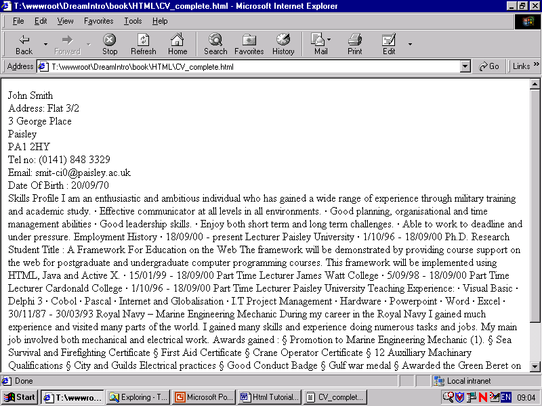
The Line Break formatting can now be seen

Another tag that can be used similarly is the paragraph tag <p>…</p> . The paragraph tag not only goes to the next line but also inserts a blank line. Therefore <p> </p> results in the same as <br/><br/>.

2.2.2 Bold Text : <b>…</b>

We can continue the formatting by bolding the text that we need to:

<b> can be read as turn bold on.
</b> can be read as turn bold off.

John Smith

<b>Address: </b> Flat 3/2 <br/>
We would also place the bold tags around the other text that we would wish to format.
3 George Place <br/>

Paisley <br/>
PA1 2HY<br/>
Tel no: (0141) 848 3329<<br/>
Email: smit-ci0@paisley.ac.uk<br/>
Date Of Birth : 20/09/70<br/>

In the Browser it will now be similar to:

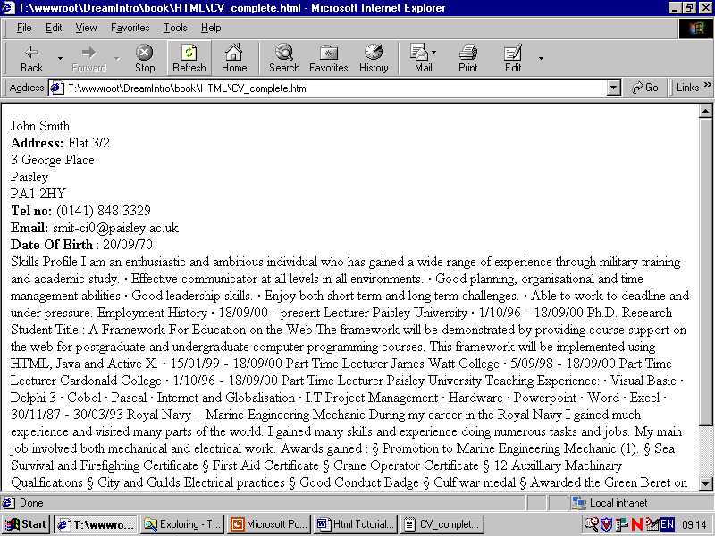

Similar to the bold tag if we wished to Italicise we would use <i>…</i> or combine for more complex formatting such as bold and italicised text. There are many more formatting tags and you should investigate their use and appearance.

2.2.3 Headers : <h1>..</h1>

Headers can come in 6 varieties h1 (being the largest) to h6 (being the smallest)

Begin Header size 2
End header size 2

<h1> John Smith</h1>

<b>Address: </b> Flat 3/2 <br/>
3 George Place <br/>

Paisley <br/>
PA1 2HY<br/>
Tel no: (0141) 848 3329<<br/>
Email: smit-ci0@paisley.ac.uk<br/>
Date Of Birth : 20/09/70<br/>

In the browser we would now have:

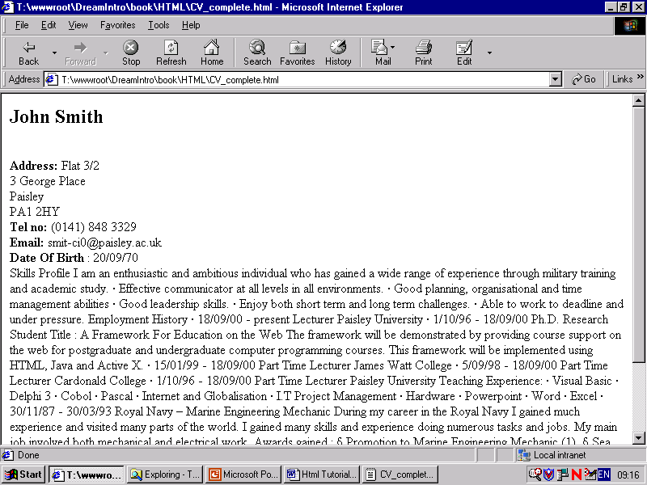

The <h2> tag in this case causes the text to resize, bold and creates a space between itself and the rest of the document, just as you would expect a heading to be.

2.2.4 Centre Text : <div align = “center”>
The Div Tag section of the block that it encloses. align = “center” will therefore centre align all that is contained within the Div tags.

<Div Align = Center>

<div align = “center”>

<h1> John Smith</h1>

<b>Address: </b> Flat 3/2 <br/>
3 George Place <br/>

Paisley <br/>
PA1 2HY<br/>
Tel no: (0141) 848 3329<<br/>
Email: smit-ci0@paisley.ac.uk<br/>
Date Of Birth : 20/09/70<br/>

</div>
<br/><br/><hr/>

The <hr/> tag stands for horizontal rule and will draw a line from one side of the screen to another.
A new line followed by another new line i.e. a line space is created with two <br/> tags.

The CV will now look as follows :

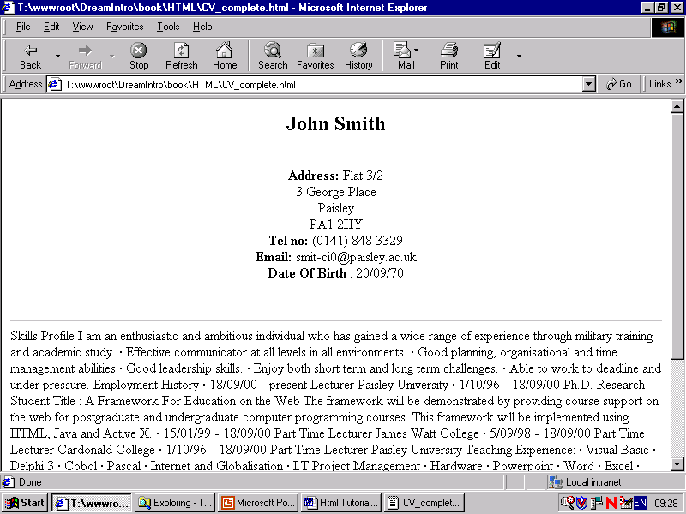

The rest of the CV can be formatted in a similar manner. An example of tags that may be used to format the rest of the CV are given here; please investigate any tags if you are unsure of how they work and what they do.
So we now have the first section formatted the way we wanted.

2.3 Introducing Lists

Lists feature very prominently in documents and fall into 2 general types

Unordered lists

- Item1
- Item2
- Item3

And ordered list:

- Item1
- Item2
- Item3

The tag <ul> signifies an unordered list and has the following format
<ul> this is the beginning of the list
<li> this would be the first item with a bullet point </li>
<li> this would be the second item with a bullet point </li>
</ul> this would signify the end of the unordered list

So for the unordered list in our Skills Section we would need the following HTML:

<h2> Skills Profile</h2>

<ul>

<li>Effective communicator at all levels in all environments. </li>

<li>Good planning, organisational and time management abilities</li>

<li>Good leadership skills. </li>

<li>Enjoy both short term and long term challenges. </li>

<li>Able to work to deadline and under pressure. </li>

</ul><br/><hr/>

And this would now look as follows in the browser:

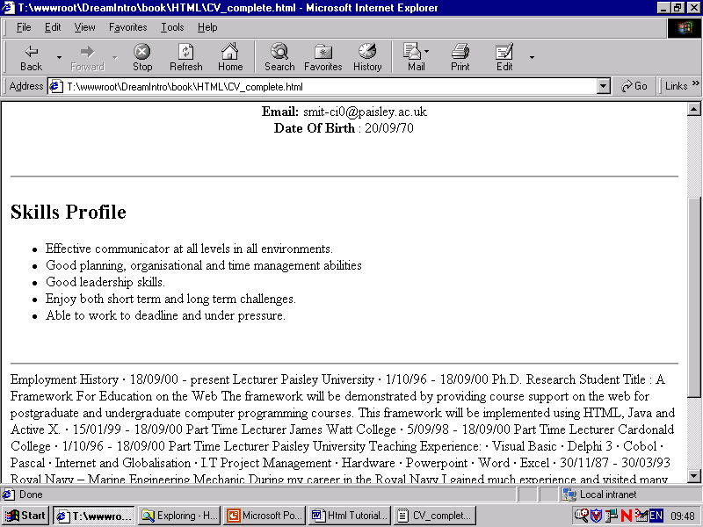
And so the second section is now formatted.

Items in ordered lists are numbered automatically by the browser

<ol>
<li>List item...</li>
- Internet and Globalisation
- I.T Project Management
- Hardware

<li>List item...</li>
<li>List item...</li>
</ol>

2.3.1 Nested Lists

We can also nest lists e.g. ordered with unordered, vice versa and in any other combination that we would wish.

<ul >
<li> Internet and Globalisation </li>
<li> I.T Project Management</li>
<ol>
<li>Networks</li>
</ol>
<li> Hardware</li>
</ul>

Would result in:


2.4 C.V. Section 3

The Employment section consists of formatting using html tags that we have already seen and so is left for an exercise and practice with using such tags as Line break, Bold, and Lists.

2.5 C.V. Section 4
Section 4 introduces more complex formatting. The browser will ignore white space and so how can we format text such as in the first part of ‘Emploment History’ and in Section 4 as seen here.

<h2> Qualifications</h2>

<ul>

<li>1994 -1996 M.Sc Information Technology Paisley University </li>

li>1988 -1993 B.A. Technology Open University</li>

</ul><p>

<b>Present Studies : </b></p> <p>

Completing Post Graduate Certificate in Tertiary Teaching Methods. <br/>
Completing Ph.D.. </p><br/><br/><hr/>

2.6 A Problem with formatting:

A problem occurs when we are trying to format text such as that in the section:

- 15/01/99 - Present Part Time Lecturer James Watt College
- 5/09/98 - Present Part Time Lecturer Cardonald College
- 1/10/96 - Present Part Time Lecturer Paisley University

This will be seen in the browser as something like the following:

- 15/01/99 – Present Part Time Lecturer James Watt College
- 5/09/98 - Present Part Time Lecturer Cardonald College
- 1/10/96 - Present Part Time Lecturer Paisley University

The formatting using spaces is ignored by the browser.

This may be formatted similarly to the word processed CV by rewriting the html to use a table such as shown here:

2.6.1 The Solution : Use TABLES

Tables have many uses in HTML
The most obvious is a table of data, but tables can also be used to place graphics on a page at just the right spot, to format text, and to simulate columns.

The <table></table> element has four sub-elements;
- Table Row <tr></tr>,
- Table Header <th></th>,
- Table Data <td></td>,
- Caption <caption></caption>

<table> The main tag. Used to tell the browser "this is a table".
<tr> TableRow defines a horizontal row of <TD> (TableData) cells.
<td> Specifies an indiviual block or cell in a table row. The individual block or cell contains the data you wish to be inserted into the table.

Therefore a table is made up of rows which in turn are made up of cells

Rows
<--This--- | ----is---- | -----a---- | ---Table-- | ----Row-->
 |  |  | cell
 | cell |  |  | cell

Colums are vertical

We can therefore format the space in the CV by using a table with something similar to the following:

<table >
Begin table

<tr><td width = "50%" align = "left" > <b> 15/01/99 - Present </b> </td>
<td align = "left"> <b> Part Time Lecturer James Watt College</b> </td></tr>

<tr><td width = "50%" align = "left" > <b> 5/09/98 - Present </b> </td>
<td align = "left" ><b> Part Time Lecturer Cardonald College</b> </td></tr>

<tr><td width = "50%" align = "left"> <b> 1/10/96 - Present </b> </td>
<td align = "left"> <b> Part Time Lecturer Paisley University </b> </td></tr>
End table
</table>

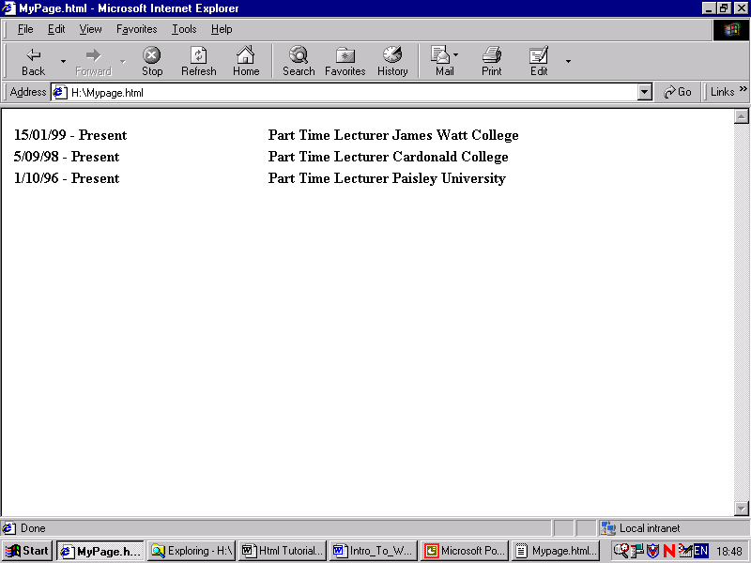

Lets look more closely at the first line of that define the tables contents:

Begin a table cell (td), the width of the cell will be 50% of the table and the alignment of the contents of the cell will be to the left.
Contents of the cell
End the first cell.
Begin table row

<tr><td width = "50%" align = "left" > <b> 15/01/99 - Present </b> </td>
<td align = "left"> <b> Part Time Lecturer James Watt College</b> </td></tr>

Begin the second cell of the row
Contents of the second cell
End the second cell
End the first row

And so at this point we have:

15/01/99 - Present | Part Time Lecturer James Watt College

Moving on to the next line:
Begin second row
First cell in the second row

<tr><td width = "50%" align = "left" > <b> 5/09/98 - Present </b> </td>

we would therefore have:

15/01/99 - Present | Part Time Lecturer James Watt College
5/09/98 - Present

And so on until the rest of the table is defined.

2.6.2 More on Tables

The following html:
Note the use of <th>…</th> to give table heading

<table>

<tr><th>Column 1 Header</th><th>Column 2 Header</th></tr><tr><tr>Row 1 - Col 1 </td><td>Row 1 - Col 2 </td></tr><tr><td>Row 2 - Col 1 </td><td>Row 2 - Col 2 </td></tr><tr><td>Row 3 - Col 1 </td><td>Row 3 - Col 2 </td></tr></table>

results in:

Colum 1 Header | Colum 2 Header
Row1 – Col 1 | Row1 – Col 2
Row2 – Col 1 | Row2 – Col 2
Row3 – Col 1 | Row3 – Col 2

2.7 Section 5
Section 5 contains no new formatting features and therefore should by now be fairly straightforward for you to understand and produce.

The HTML used was as follows:

<h2>Interests</h2>

<ul>

<li>Education and Learning</li>

<li>Web Based Technology</li>

<li>Sports and Martial Arts</li>

<li>Outdoor Pursuits</li>

</ul>

2.8 Lab Exercises:

1. Fully format the CV shown for practice.

2. Make your own or a complete fantasy CV in HTML, be creative in this exercise, for example you can be the king of the world, empress of the universe, rock star and a supermodel in your spare time – anything.

HTML Lab 2

1. Creating Anchors

The Anchor tag creates a hotspot, known as a hypertext reference, on which the user can click and gain access to another document or particular place within a document.
This allows us to navigate from one position in a web document to another page, from page to page in a web site and from web site to web site where the sites may be on different continents.

1.1 Including Anchor tags in the CV document

Create hyperlinks within your CV that provide hotspots to the different sections of your CV. An example of this is shown below:

When the user clicks on these hypertext references (hotspots) it will take us to the relevant section.

Personal Details
Skills Profile

Employment History
Qualifications

Interests
Clicking on the hotspot 'Personal Details' brings us to this spot.

John Smith
Clicking on 'Skills Profile takes us to this relevant section of the document.
Address: Flat 3/2
3 George Place
Paisley
PA1 2HY
Tel no: (0141) 848 3329
Email: smit-ci0@paisley.ac.uk
Date Of Birth : 20/09/70

Skills Profile
….
Clicking on Employment history will bring us to this relevant section of the document.

Employment History
….

Qualifications
Clicking on the hypertext link 'Qualifications' will take us to this relevant section.
….

Interests
Clicking on the hypertext link 'Qualifications' will take us to this relevant section.

….

1.2 Anchors to particular places within a document

The hypertext reference to a position within a document comes in two parts:

- Part 1: The hypertext reference (Hotspot) itself;
- Part 2: The place that will be linked to must be named i.e. bookmarked.

Part 1 : The hypertext Reference
The # sign signifies that the reference is within the same document.

Text here will usually be blue in colour and be the hotspot the user will see and click on.

<a href = “#Personal”>Personal Details</a>
This closing tag signifies the end of the anchor.

#Personal matches the link-to name.
The anchor tag opens with <a and the href stands for Hypertext reference. The text enclosed in quotes is the name of the reference to link to

The named link (i.e. the part being linked to) appears as ordinary tet as it is not itself a hotspot (in this case John Smith).

Part 2:
The closing tag.

<a name = “#Personal”>John Smith </a>
The anchor link is named

<a href = “#Personal”>Personal Details</a>

<a name = “#Personal”>John Smith </a>
You have seen how this one works - now all the reset work in a similar way.
Address: Flat 3/2
3 George Place Paisley
…….

Here is a list of references that may be used to create links to the document sections:

The text ‘Employment history ‘would appear in blue and be a hotspot to the section with the Anchor name of Employment.

<a href = “#Personal”>Personal Details</a>
<a href = “#Skills”>Skills Profile</a>

<a href = “#Employment”>Employment History</a>
<a href = “#Qualifications”>Qualifications</a>
<a href = “#Interests”>Interests</a>

<a name = “#Personal”>John Smith </a>
Address: Flat 3/2
3 George Place Paisley
…….

<a name = “ Employment”> Employment History</a>

- 1/10/96 - present Ph.D. Research Student

Title : A Framework For Education On The Web

Linking back to the top of the document

Once you have hyper-linked to a specific part of the document you may wish to return to the top of the document. Links can be provided to do this in the same way:

<a name = “#Top”>Curriculum Vitae</a>

<a href = “#Personal”>Personal Details</a>
…
<a href = “#Interests”>Interests</a>

<a name = “#Personal”>John Smith </a>
…

Skills Profile
….

<a href = “#Top”>Top</a>

Employment History
….

<a href = “#Top”>Top</a>
Each of these would link to the anchor named 'Top'
Qualifications
….

<a href = “#Top”>Top</a>

Interests
…

<a href = “#Top”>Top</a>

1.3 Linking to other documents

Consider 2 documents: one your CV and the other your home page. How would you link from one to the other?

Curriculum Vitae

Personal Details
Skills Profile

Employment History
Qualifications
Interests
Home Page

John Smith

Welcome To My
Homepage

….

…

If the home page document was saved in the same folder as the CV document with the name Myhomepage.html then it would be:

<a href = “Myhomepage.html”> Home Page</a>

The name of the document becomes the hypertext reference link.

1.4 Linking to other sites

To link to other sites we need to know the web address (the Universal Resource Locator) and then use the Anchor tag in the same way:

<a href = “sitename\filename”> link text </a>

This link will take you to the default page of the University of the West of Scotland:

<a href =” www.uws.ac.uk”> The University of the West of Scotland</a>

This link will take you directly to the courses web page:

1.5 Linking to a particular section within another document

To link to a particular section within the document we need to combine the two methods already seen. For example if you would want to link to the Employment section within you CV which is as named earlier:

<a name = “ Employment”> Employment History</a>

Then we must create a hyperlink that includes both the document name and the specific section as shown here:

<a href = "MyCV.html#Employment" My employment History</a>
Curriculum Vitae

Personal Details
Skills Profile

Employment History
Qualifications
Interests
Home Page

John Smith

<a name = “ Employment”> Employment History</a>

- 1/10/96 - present Ph.D. Research Student
Title : A Framework For Education On The Web

Welcome To My
Homepage

….

…
<a href = "MyCV.html#Employment" My employment History</a>

This results in a link being created
This is named as a link.

John Smith

Employment History

- 1/10/96 - present Research Student
Title : A Framework For Education On The Web

Welcome To My
Homepage

…….
This link will take the user to the named section within the named document
….

My employment History

1.6 Lab Exercises

1. Re format your own CV to have hyperlinked sections.
2. Create a simple home page include any content you wish such as about yourself , your interests, family, friends and hobbies.
3. Create a link from your CV to your home page and vice versa.

HTML Lab 3

1. IMAGES

The Web began its life as a purely text-based medium, but with the ever increasing uses that the internet is being put to the role of graphics has become ever more important over recent years. The old Chinese saying ‘1 picture is worth a thousand words’ is very true in many situations and has obvious advantage both for information and producing aesthetically pleasing pages.

If you want to use graphics in your web pages you will need to use the HTML image tag <img/>. The <img/> tag is used to tell an Internet browser that an image needs to be loaded onto the page. Remember that this tag, unlike many other HTML tags does not need a closing tag.
Here is an example of its usage:

<img src="myimage.gif" alt = “myimage” /> (you will use the name of your image file in place of myimage.gif and remember not to use spaces in between words when naming your files). The alt tag must be used for alternative text; if the browser does not support images the text will be shown instead.
src is simply short for "Source", the "Image Source". It names the image file you want to place on the tag.
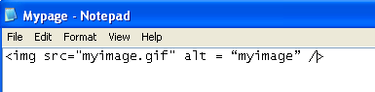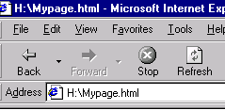

This will place the image on the web page

1.1 Image Positioning

The image will be positioned at the point of insertion in the html code. As you can see from the following code the image tag is used after the word inserted

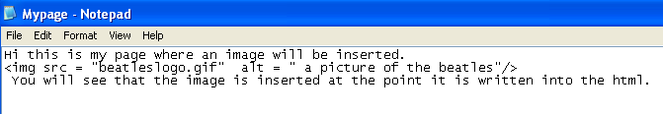
and this is where the image will appear on the page as seen below:
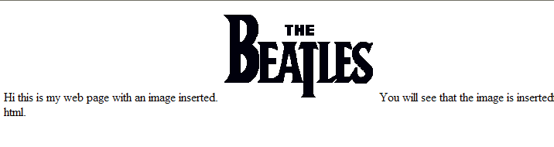
This is the position that the image is inserted i.e. after the word inserted

We can format the html so that it will look a bit better. Below we use the <br/> tags to create a new line before the image and a <br/> tag after the image tag:
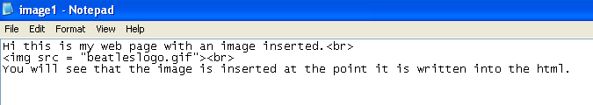

Hi this is my web page with an image inserted.<br/>
<img src = “beatleslogo.gif” alt = “ a picture of the beatles”/> <br/>
You will see that the image is inserted at the point it is written into the html.
The result of this code can be seen below:
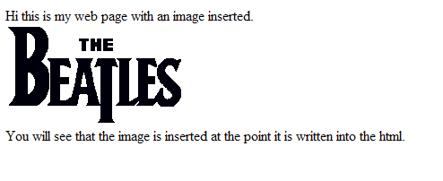

For more complex formatting tables could be used and images placed inside the cells.

1.2 Images and Paths
When using the name of the file the full path must be given, the above example assumes that the image is within the same directory as the web page that it is linked to.

1.2.1 Relative Paths
When linking to an internal document on the local web server the relative path must also be given (or absolute but for portability relative is better). For example:
/imgdir/image2.gif – a relative path, which offers better portability when transferring from a local site to an Internet service provider.

If we develop a site called WebPages on the local machine and create links, for example:
To link from My page.html using /imgdir/image2.gif

- go to imgdir Directory

- find image2.gif

Mypage.html
Webpages
directory
C:
imgdir
Directory
image2.gif

If we were to move my WebPages directory onto the internet to http:myserver\
To link from My page.html using /imgdir/image2.gif

- go to imgdir Directory

- find image2.gif

Mypage.html
Webpages
directory
http:
myserver:
imgdir
Directory
image2.gif

The relative path still holds good

1.2.2 Absolute Path
C:inetpub/webpages/ imgdir/image2.gif – an absolute path that may cause problems when transferring from a local site to an Internet service provider

To link from My page.html using C:inetpub/webpages/ imgdir/image2.gif
1. Go to C:
Mypage.html
Webpages
directory
C:
imgdir
Directory
image2.gif

2. Go to Webpages
3. Go to imgdir
4. Find image2.gif

This part will no longer work

To link from My page.html using C:inetpub/webpages/ imgdir/image2.gif
1. Go to C:
Mypage.html
http:
myserver:
Webpages
directory
imgdir
Directory
image2.gif

2. Go to Webpages
3. Go to imgdir
4. Find image2.gif

1.2.3 Linking to External Files
Sources can also be external to images on other web servers:
http://www.imgs.com/dir/image1.gif

Mypage.html
Webpages
directory
http:
myserver:

http://www.imgs.com:
dir

image2.gif

1.3 The Image as a Hotspot Hyperlink

You can use the image as within an anchor tag and turn any image into a clickable link that will take you to another web page or another position within the current one.
Here is an example of the code needed to do this:
<a href ="myhomepage.html"><img src="grad.gif" alt = “home page picture link" /></a>

The image becomes a clickable hotspot which will take the user to the named HTML document; in this case MyHomePage.html.

Welcome To My
Homepage

….

Therefore when the image is surrounded by anchor tags <a>…</a> it can be used in the same way as text based hyperlinks and can be used to access different pages and positions.

1.4 Image Attributes
Attributes that will set the height and width:
To specify a particular size for your graphics and images you will use the Width and Height attributes within the Image Tag.
width (WIDTH) - This is the width of the image in pixels and this value can be obtained from a graphics program or can be left unspecified
height (HEIGHT) - This is the height of the image in pixels

<img src= "myimage.gif" alt = “grad picture” width="200" height="300" />

200 pixels
300 pixels

Setting a border for the image or removing the border
Border (BORDER) - This is for a border around the image, specified in pixels
<img src= "myimage.gif" alt = “grad picture” border ="1" />

Border = “2” would give a thicker border of 2 pixels.
However these formatting attributes are depracated for xhtml and styles should be used instead.

1.5 Image Types

On the Web the three most common graphic file formats are:

- GIF (Graphics Interchange Format) - GIF is the smallest file size type for graphic images on the web and is therefore the most commonly used. Primarily they are most useful for example to display company logos, titles, or cartoon-type drawings. The GIF format supports 256 (8-bit) colours. However, it should be noted that there are only 216 designated web-safe colours i.e. guaranteed rendered in that colour.

- JPEG (Joint Photographic Experts Group) - The main advantage of JPEG (file extension .jpg) is the ability to handle images containing millions of colours (24-bit). This makes JPEG an ideal choice for saving variable tone images such as photographs.

- Portable Network Graphics (PNG) brought out to replace gif format png is a lossless compression algorithm which means that when re-constructed the original data is maintained as compared to a lossy compression algorithm like the gif in which detail is lost for example if the image is enlarged.

1.6 Lab Exercises

Reformat you cv to include your picture image.
Re-format your home page and include images.

